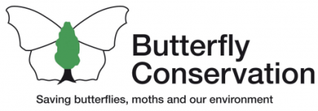

Dear Colleague

Butterfly Conservation are - for the first time - offering a special [free] opportunity to Gloucestershire students doing their Duke of Edinburgh’s Silver Award.

With an itinerary specially designed to help students explore the secret life of butterflies, moths and caterpillars, those who follow the programme will complete their Duke of Edinburgh Volunteering section.

With a number of potential activities, students can discuss building a schedule that suits them. Activities include a mix of lending a helping hand on our nature reserves, surveying for butterflies, volunteering at events or working with a school / organisation to create butterfly friendly habitat.

If students would like a career in conservation or care about nature, this placement could be a great opportunity for them.

Please see the attached flyer - designed to be circulated to students - for more details.

Students should express an interest in the first instance by emailing DofE@gloucestershire-butterflies.org.uk from an email account belonging to a responsible adult, supervisor or teacher including a short introduction to themselves and a short explanation of why they would like to complete their Volunteering section with us. This could be written, filmed or recorded and should be brief.

Organisations running the Duke of Edinburgh’s Award can contact this email address with further questions.

We look forward to hearing from you.

Kind regards,

Butterfly Conservation Gloucestershire Branch

